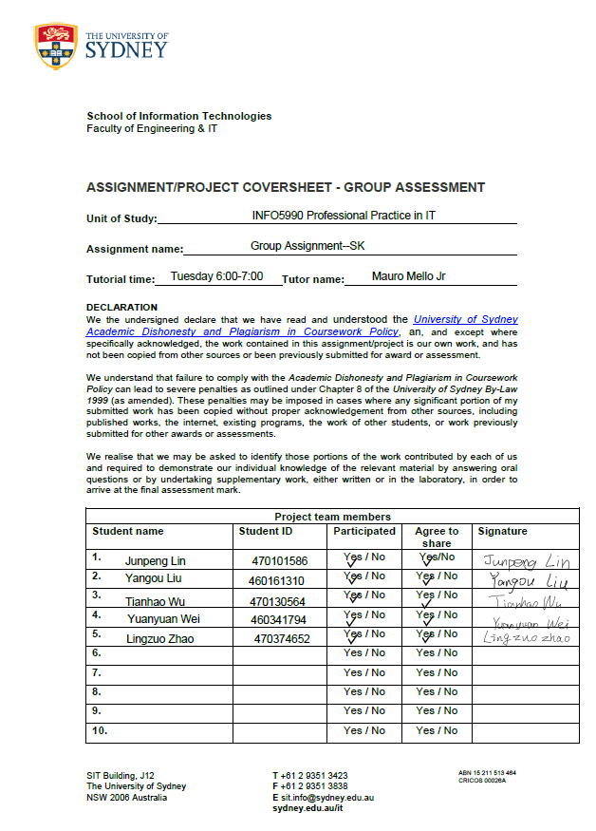
1 Introduction

Clinical imaging service plays a significant role in hospital diagnosing. In 2015, there were more than 60 billion images generated in the U.S, it required 31000 radiologists to read and interpret an image every second of every working day (IBM Watson health, 2017). Moreover, misdiagnosis also accounted for a large proportion in the medical accident. In order to relieve doctors’ working stress as well as reduce the risk of misdiagnosing, the project aims to provide computer-aided clinical imaging diagnose service combining with artificial intelligence (AI), machine learning and data mining technology, which offer automatic therapy method after learning plenty of cases in the healthcare industry.

2 Current Project Audit

According to the statistic from the American College of Cardiology, if using properly, the imaging quality improvement initiative in FOCUS (Formation of Optimal Cardiovascular Utilization Strategies) shows that applying AI tracking appropriate use criteria can reduce incorrect implement of diagnostic imaging, which assist physicians focus on practice guidelines as well as follow appropriate use criteria. The proportion of inappropriate case decreased from 10% to 5% after the use of advanced, quality-improvement software [1]. Physicians are able to provide an accurate interpretation of cardiac imaging studies by taking advantage of AI tools. Besides, the computer-aided system creates an opportunity for physicians spend more time with patient inquiry the current condition and less time face to a computer. The cost of healthcare can also decrease because utilised AI application can reduce unnecessary testing and decrease the disparity. It has the potential to improve the efficiency of a hospital as well as reduce hospital admission and waiting time for patients [2].
There are also some obstacles that we have to face before entering the healthcare industry. First, AI used in diagnose must be totally accepted by users and tightly interfaced with electronic medical record systems, which means we need to reach an agreement with the hospital and the software must be highly compatible. Second, the accuracy of the system for diagnosing should do the first-class level. The outcomes for a patient which need large numbers of data repositories and advanced deep learning algorism should from an ‘expert’ perspective. Another challenge is about patient privacy and information security. Although federal regulations have the strict restriction in health care data, the software risk of privacy still exist.
3 Project justification:

3.1 Background & Solutions
At present, reading medical photography is a time consuming work for doctors, patients are likely to wait for a certain period of time to get their reports on the photography. The SK Super1 give solution to this situation. As the diagram shows, our project would develop a AI medical-film-analyzing system which is composed of two parts. The first part is the client software, which is installed on the computers of hospitals and can scan all kinds of medical photography (e.g. CT,NMRI).The client software will then upload the images to our company’s server and thus the images will be analyzed by our AI, which is the main part of our project. The AI will search for all the similar and associated cases in its database and throughout the internet, combine all the information and come up with the most accurate diagnoses. Machine learning is involved in this process, so that the more cases the AI analyzes, the “smarter” it will become. The result will be transmitted back to the client software or be emailed to the patient.
3.2 Business model
SK main stream business is selling the SK Super1 System, help our customers with the maintenance of the software and providing the with other related services. Our target customers are hospitals and patients. By cooperating with hospitals, we will hopefully create a comprehensive medical-information system. We also encourage individual patients to set up their personal profile in our system. The more data we get from hospitals and individuals, the more complete our database will become, which allows our AI to be more powerful.
3.3Revenue
There are two main source of revenue for our project. First of all, as mentioned above, we cooperate with hospitals, offering them a free trial period/version of our system. If the hospital decides to use our system, than they have to buy our system and pay a small amount of fee annually for upgrades. Patients are encouraged to set up their own individual profile in our system, so that their personal medical photography can be recorded and the AI may know better about their individual medical history, resulting in better diagnoses. This service is free. What we charge for is health reports given by our AI based on the previous records of an individual. This report may offer our customers with health advices and illness predictions. However, this type of fees are rather low as our main purpose of doing so is to attract more users.
3.4Benefits
3.4.1 User Benefits
Doctors’ burden will be eased if the hospital uses SK Super1. Not only the work of reading medical films will be done by our system, the AI may also support doctors by machine-generated suggestions. The risk of misdiagnosing will decrease as the advices given by the AI are based on massive data samples. In one word, the hospital’s efficiency will be promoted.
At present, patients often have to wait for a certain period of time to get their medical photography report. By using our system, this period of time can be saved. The analytical results can be emailed to the client as quick as possible. Patients who agree to create their individual profile will be provided a free electronical medical record, which can be used in multiple hospitals as long as the hospital uses our system.
3.4.2Stakeholder Benefits
We are a company that concentrates our effort mainly on the software and the AI algorithm, we have the top software engineers and we are inviting leading medical experts to work with our projects, thus we are more likely to provide more professional solution than our competitors who produce both software and hardware. Since there’s no hardware manufacturing, the investment is rather low. Once our system is implemented in hospitals, the AI will grow to be more and more powerful. According to the learning-effect theory [3], our design has a great potential of being dominate.

4. Implementation analysis
  - Implementation strategy
While implementing project, there will be various aspects of barriers:
- The shortage of hospital side management involvement [4]
- Misunderstanding during information communicating leads to poor project implementation
- The poor contractor project planning.
The barriers above will be tough obstacles for the project implementing, so they should be considered carefully to overcome.
4.2 .Market analysis
4.2.1 SWOT analysis
The market analysis of the project is based on SWOT analysis, which is presented in the form of the table 4.1 [5] in order to evaluate the four elements of organization, project and market.
Table 4.1 SWOT Analysis
- Strengths: The latest technology ensure the accuracy of the test results, reducing the misdiagnosis rate of diagnosis. Considering hospital, the system could decrease the amount of doctors, contributing to more resources into other areas.
- Weaknesses: The cost of the training of initial data is high, there are some difficulties in approach to the investor.
- Opportunities: There are a large number of patients in need of imaging analysis in Australia [3]. It is a time for the product to improve the situation.
- Threats: There are some similar companies, such as Siemens Healthineers [6], selling medical machines to hospitals. These competitors occupied the market firstly, to bring the product into hamper.
Based on the SWOT analysis, the product has its own advantages, resulting in the profits of the hospital and improvement of life quality for human in Australia.
4.2.2 Market size
It is necessary for companies and investors to analyze the market size before launching a new product. According to Australian Institute of Health and Welfare [7], there have been 10.2 million hospitalizations in Australia during 2014-2015. Most hospitalized patients need image analysis and there will be about 10 million patients who become targeted customers for the product. Considering the latest technology support, the system could analyze CT, MRI, PET, SPECT and other modalities, including the application from cardiology, orthopedic, oncology, neurology and others. All the patients who need image analysis could use the system in the hospital or log in the website. The big area of the market guarantees the success of the development of the product.
4.2.3 Marketing strategy
4.2.3.1 Target customers
The target customers of the system are the patients who are in need of image analysis. The patients and hospitals would choose this system instead of the competitors’ system because of the advantages of technology and services. The artificial intelligence technology and the company’s concentration on the exploitation of software, making the accuracy of test higher than others. Compared to competitor’s system, such as Siemens Healthineers [6] which only sell machine to the hospital, SK company could not only provide system to the hospitals to analyze image but also build personal image profile for each patients. This additional service makes the different from other competitors, getting more competitive.
4.2.3.2 Marketing strategy model (4Ps)
SK company use the 4Ps strategy for the marketing, this strategy could be presented in the form of the figure.

Figure 4.1 4Ps
Product: SK Company provide a system that could analyze medical images for patients in the hospital or in the website.
Price: Hospital could have a test period for the system to test the performance of the product compared to the others. The test time could get more market for the SK Company and build the mass basis among the target customers. After the test period, the price of the system is lower than the competitors.
Place: SK Company will be located in the City of Sydney. In addition, the system is a cloud platform, the patient could log in the website anywhere instead of going to the hospital.
Promotion: Cooperate with the hospital, the advertisement of the product will be broadcasted. In 2019, 80% hospitals in Sydney will be covered by the market plan of the SK Company.

5. Project Finance
5.1 Project Sales Predicted
SK Company strategy can be divided into different stages: research stage, growth stage and saturate stage. The first stage is research status that company does not makes profits from the project but huge expenses (2017.6~2017.11). When the first generation product comes out, our company begin to gain profit by it. During the growth period (2017.12~2019), the company will accumulate capital exponentially. Once reaching the roof of the capital, SK Company will be more likely to be stable development.
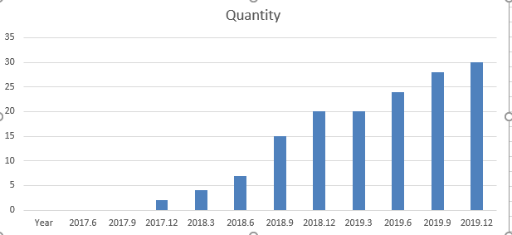
Figure 5.1 Quantities of Sales
At the last quarter in 2017, we plan to sell few copies of software. While receiving more orders, our company will develop the larger scale of the implementation team and marketing teams. What’s more, with experience accumulated, the implementation provision will increase which can also improve the work efficiency.
Assuming that the price of each product is $50,000. Combining the graph above and the price, we can obtain the table that displays as below:
Table 5.1 Predicted Sales Value
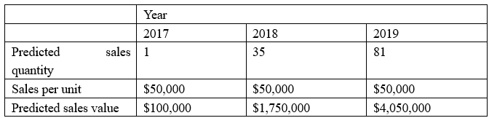5.2 Project Expense Predicted
The major expense can be identified as human resources costs, IT and Medical equipment investment, research costs, marketing costs, outsourcing costs.
Table 5.2 Predicted Expense
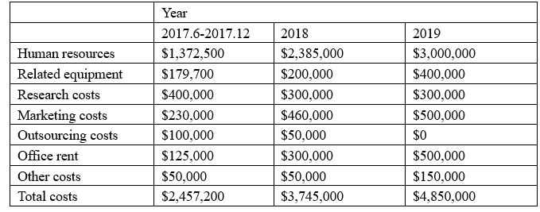
The location of company set up at the City of Sydney. Notably “Other costs” from the table refers to the traveling fees, unexpected fees and so on.
In the first year, the major job is collecting data, analyzing data and building up the cloud platform. In the perspective of human resource, SK will employ top experts to form IT research department. Meanwhile, to establish Medical Centre, SK will employ full-time medical experts as well as external doctors from other organizations or technologists from universities to contribute the project.
In 2018, the significant change in the company is setting up marketing department and implementation teams to support the product selling. SK will consider hiring more software engineers to maintain current systems and assist the client to install systems.
In 2019, according to development strategy，the goals of marketing is covering major hospitals in Sydney. SK will rent more reliable and larger capacity of cloud servers. At the same time, marketing and implementation teams are growing rapidly.
Estimated return
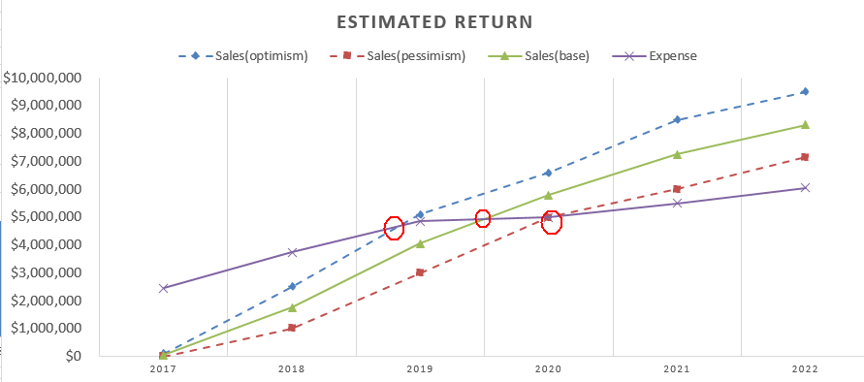
Figure 5.2 Estimated Return
It is notable that the number of Sales will surpass the number of Expense. SK fully believe that the product “SK Super 1” will be popular by word of mouth among hospital. The blue line that is optimistic estimation will surpass the purple line that represents expense in 2019. The green line will exceed the purple line in last 2019 while the breakeven point will happen to the red line in 2020.

6. Research methods
There are some methods in research, such as experiments, surveys, questionnaires, interviews, case studies, literature and field investigation. In this research, SK Company use the method of literature investigation [8]. This method uses relevant research and analysis to assume and predict the research. In the market research, literature investigation is a usual method to collect and the special model to analyze data. Only when the data and material is not enough, the field investigation should be considered.

7. Project Plan
7.1 Timeline & Milestone

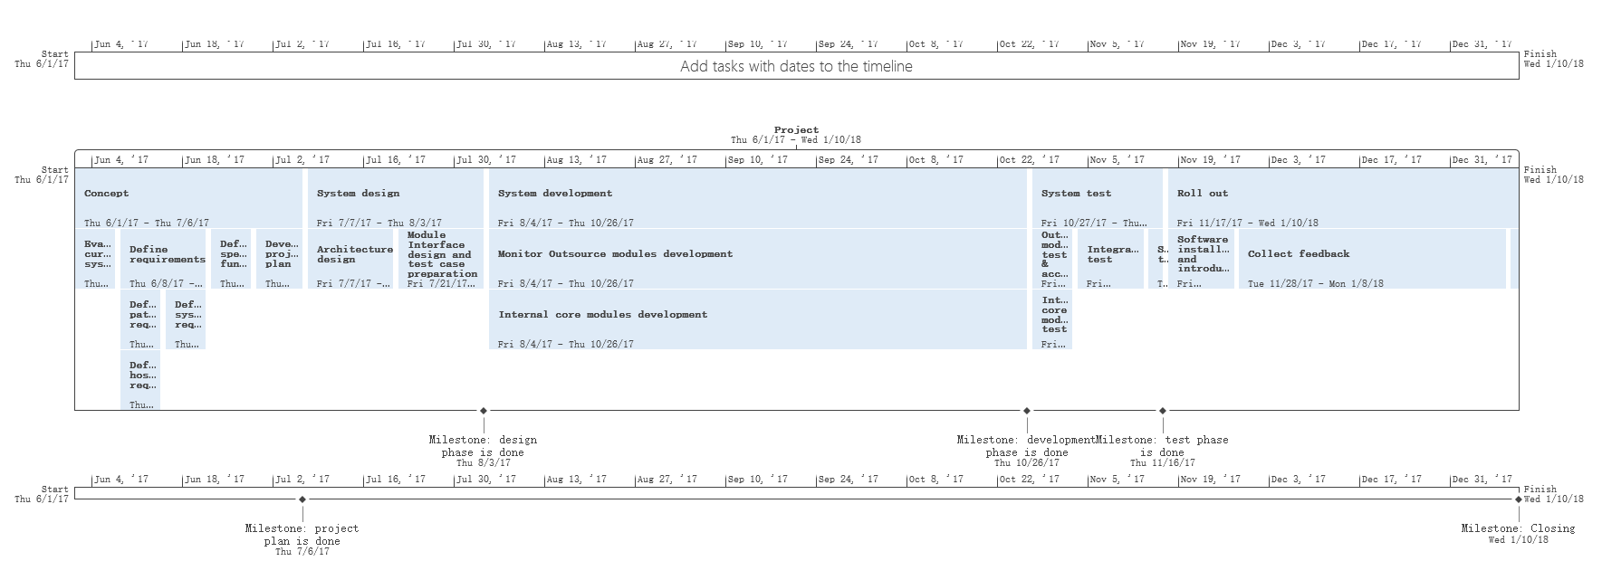

7.2 WBS

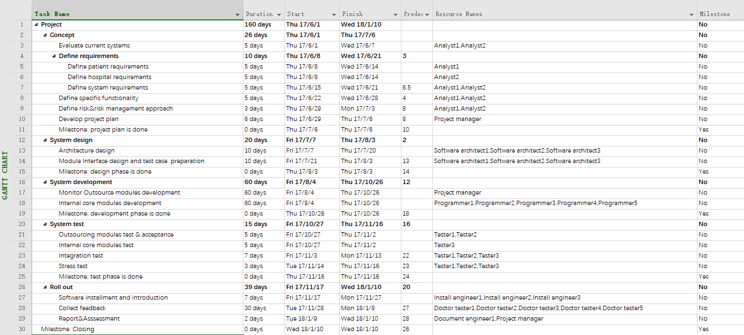

7.3 Resources

Resources | Details
Project team | A team of all the members mentioned in the WBS  Project manager(1)  Analyst(2)  Software Architect(3)  Document engineer(2)  Programmer(5)  Tester(3)  Install engineer(3)
Hardware | computers(20),servers（decide after system design)
Licensed software | Decide after system design
Data sources | purchase
Outsourcing Contractor | Decide after system design
Office venue | Company support
Doctor tester | Invite doctors from hospitals
Collaboration system | Company support
AI senior engineer | Company support
Resource table

7.4 Gantt Chart

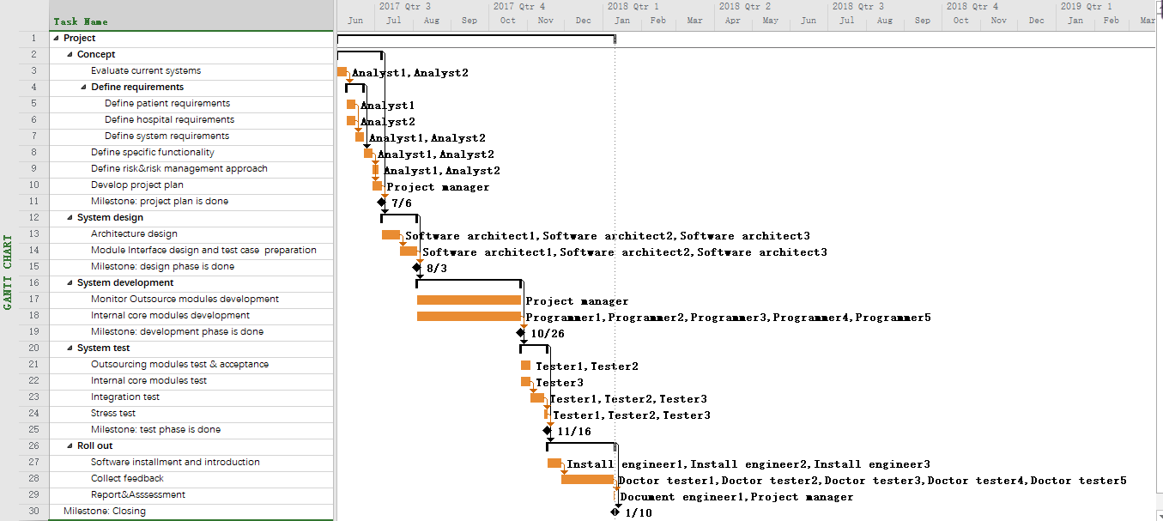

7.5 Risk management approach
7.5.1 Risk breakdown structure

According to Risks breakdown structure shown below to identify and categorize risks [9]

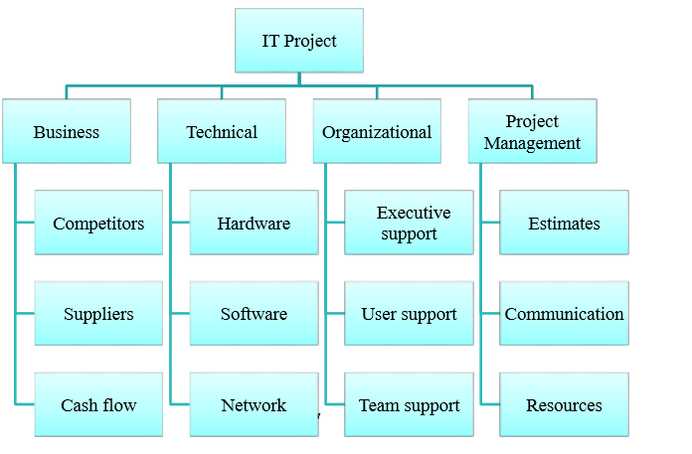
Risks breakdown structure

7.5.2 Risk register and monitor
Fill the identified risk in Risk register table show below
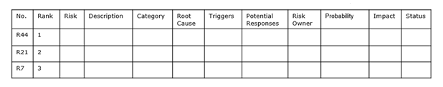
Risk register table
Establish a periodic review of the top 10 project risk items during project life cycle. List the current ranking, previous ranking, number of times the risk appears on the list over a period of time, and a summary of progress made in resolving the risk item
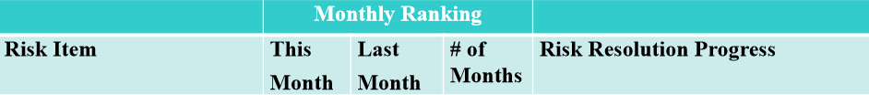
Top 10 Risk Item Tracking
7.5.3 Planning the risk response
There are four types of risk responses, that is:
Avoidance: eliminating a specific threat or risk, usually by eliminating its causes 
Mitigation: Implies that an identifiable action(s) can be taken to reduce the negative outcomes of a risk –by reducing its impact, or reducing it likelihood 
Transfer: shifting the consequence of a risk and responsibility for its management to a third party 
Accept: accepting the consequences should a risk occur
7.6 Identified high risks of the project
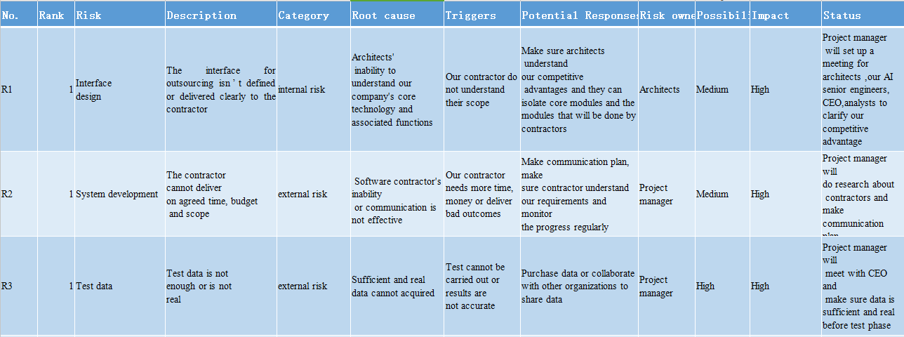

Reference:
[1] Saifi, S., Taylor, A.J., Allen,H. & Hendel, R. (2013).The use of a learning community and online evaluation of utilisation for SPECT myocardial perfusion imaging. JACC Cardiovasc Imaging, 6(7), 823–9.
[2] Dilsizian, S. E.& Siegel, E. L. (2014). Artificial intelligence in medicine and cardiac imaging: harnessing big data and advanced computing to provide personalised medical diagnosis and treatment. Current cardiology reports, 16(1), 1-8.
[3] Schilling, M. A. (2013). Strategic management of technological innovation. New York, NY, McGraw-Hill.
[4] Whittaker, B. (1999). What went wrong? Unsuccessful information technology projects. Information Management & Computer Security, 7(1), 23-29.
[5] Hay, G.J. & Castilla, G. (2006). Object-Based Image Analysis: Strengths, Weaknesses, Opportunities and Threats (SWOT). Foothills Facility for Remote Sensing and GIScience, University of Calgary.
[6] SIEMENS Healthineers. Retrieved from: https://www.healthcare.siemens.com.au
[7] Australian Government, Australian Institute of Health and Welfare. (2015). Australia’s hospital 2014-15 at a glance. Retrieved from:
http://www.aihw.gov.au/WorkArea/DownloadAsset.aspx?id=60129556125
[8] Literature Review. Retrieved from:
http://linguistics.byu.edu/faculty/henrichsen/ResearchMethods/RM_3_03.html
[9] Schwalbe, K. (2015). Information technology project management. 8th ed. Boston, Mass.: Thomson Course Technology

